Llangennech service with four residents

We are three adults who live together in a purpose built house in Llangennech, near Llanelli. We hope that someone else will come to live here soon.

We like lots of different activities: sports, shopping, going out to eat, baking and cooking, going on holiday and visiting the beach. We work and play on our computers and phones. We do art courses and bikeability.

Some of us can speak, others are non-verbal.

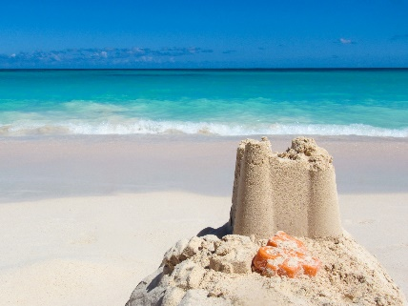



[This Photo](https://www.freefoodphotos.com/imagelibrary/seasonal/slides/christmas_kids_baking.html) by Unknown Author is licensed under [CC BY](https://creativecommons.org/licenses/by/3.0/)

What is important to us

* Some of us can make day to day decisions, some of us need more support.
* We all like to be included in any decisions that affect us.
* We want to be included in conversations and can get distressed if people talk about us rather than to us.
* We like to be as independent as possible.
* We need your support to keep healthy and manage our medical conditions.
* Some of us use wheelchairs and need support with our mobility

What people say about us:

* I’m sociable
* I have a good sense of humour
* I’m funny
* I don’t like loud noises
* I let people know what I think
* I don’t like fireworks
* I’m a good dancer
* I can be messy at times
* I don’t like waiting
* I love to be busy
* I get along with everyone
* I don’t like the dark
* I love nature and gardening