

**About the job**

|  |  |
| --- | --- |
| http://intranet.rms.ad/accessibleimages/lores_images/Desk_Work-4.jpg | The job is called a Project officer |
|  | You will be working on helping Carmarthenshire to be a better place for people with a learning disability to live in. |
| You will contact people in the local area to understand what is important to them and their ideas for a better community. |
| The Manager | The manager for this job is Laura. You will also have a Project officer supporter. |
|  | The job will be based in Carmarthenshire. |
| 16 | You will be working 16 hours a week. You will be working from an office and will be visiting different venues and possibly peoples homes. |

**What will the Community Connector do?**

There are 5 main roles for your job:

|  |  |
| --- | --- |
| **Team Player** | You will work with lots of different people at Mencap and outside of Mencap.  You need to be a team player.  You will build good relationships with people.  You will work closely with the Community Partners |
| **Project Officer** | You will be working in all areas of Carmarthenshire. |
| You will help to research and contact local organisations, individuals and groups in the area.  This will include:-   * Supporting the Community Partners to different events * Working with Peoples First on the Citizen Panel * Mencap has a Big Plan which is community lead, you will be contributing to this. * Find out what is important to the people living in the area * Building relationships with people with a learning disability, improving peoples lives and enabling them to make their own decisions * ideas on how to make the local area better for people with a learning disability   You will also help people to share their ideas.  You will share ideas about how to make Carmarthenshire a better place for everyone. This will include thinking of new activities and ideas. |
| **Role Model** | You will tell people about the work that Mencap does.  You will tell people about why it is important to support people with a learning disability and include them in the community.  You will help to reduce negative attitudes.  You will always be friendly and helpful. |
| **Travel**  Transport | The work will take place all around Carmarthenshire.  You will need to be able to travel to different places.  You will need to be able to travel independently. |

**Other important information**

|  |  |
| --- | --- |
| DaysTime duration | Meetings and events can be on different days and you will need to be free for different times. |
| Idea2 | You should have a good understanding of the Carmarthenshire community and what happens locally. |
|  | You will be willing to learn how to use IT and social media. |
| Rights man | You should be confident to talk to new people and build relationships with individuals and organisations. |
|  | You can talk in front of large groups of people. |
|  | If you are asked to come for an interview, you will need to bring your ID documents with you. This will include:   * A passport or your birth certificate * National Insurance number |

**Mencap’s Values**

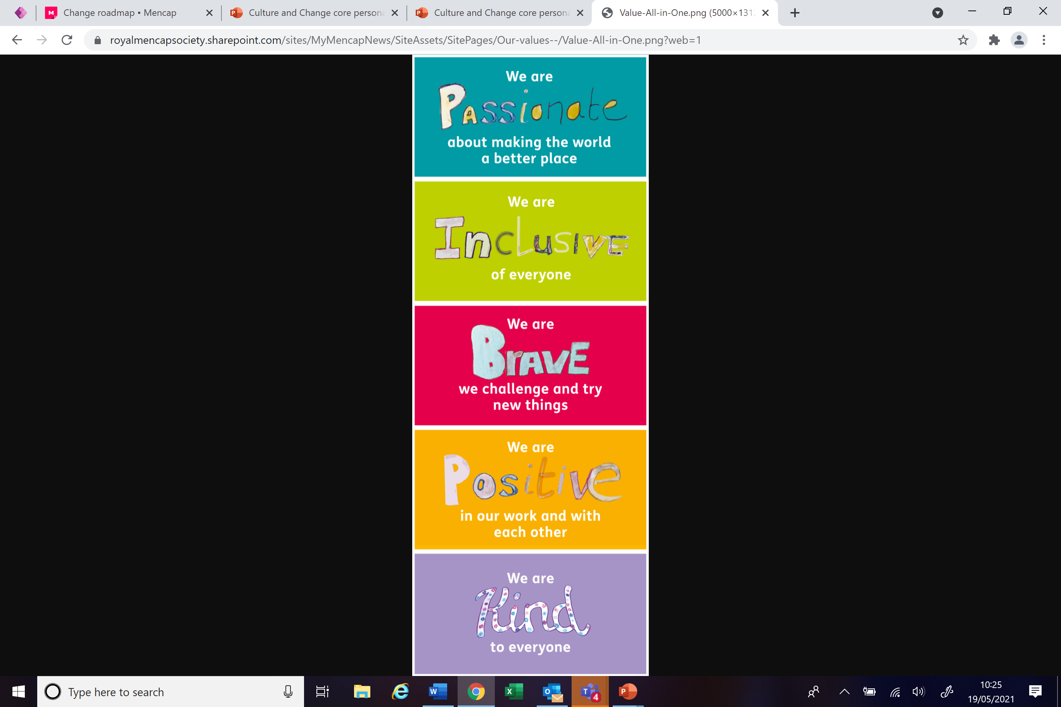

* You will be **inclusive** by working with different people and listening to everyone.
* You will be **passionate** about helping the community.
* You will be **kind** to everyone you work with.
* You will be **positive** in how you work with other people.
* You will be **brave** to meet new people and support their ideas.