Healthier Me Champion Pembrokeshire and Ceredigion
This is a role for a person with a learning disability.

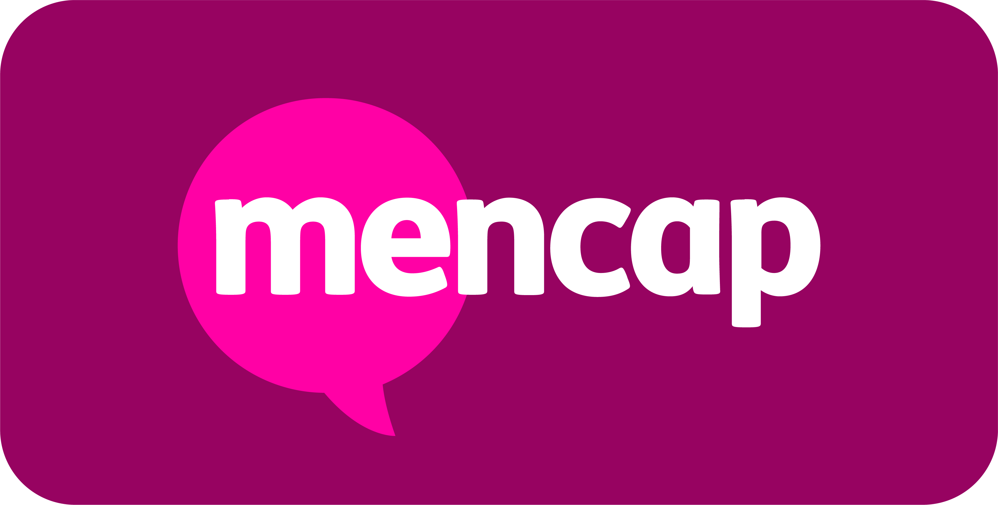

About the Team and the Role
This role is for 16 hours per month. Working days and times will vary.
The role pays £12.21 per hour. This role is until October 2027.
The Healthier Me Champion will be part of our exciting new Healthier Me programme at Mencap.
The Healthier Me programme wants to improve health and wellbeing for and with people with a learning disability.
As a Healthier Me Champion you will work in your local area with your manager, the Healthier Me Coach. You might be asked to do some work from home .
Healthier Me Champions will:
- Encourage people with a learning disability to make healthy choices.
- Help local groups and services to be more accessible to people with a learning disability.
- Help the Healthier Me Coach (your manager) to run training sessions and meetings.
- Meet people in Mencap services and tell them about Healthier Me.
- Join online meetings with other Healthier Me Champions around the UK to share your ideas and experiences and listen to others.


What you will bring to the role
We are looking for someone who:
- Can work flexible hours on different days and times.
- Lives in the area where this job is based.
- Be willing to go to different places for work.
- Is willing to try and learn new things.
- Enjoys meeting new people.
- Is Positive, Kind, Inclusive, Brave and Passionate – these are Mencap’s values and they are very important to us.
- Can use a computer, smart phone or tablet.
- Has knowledge of the local area.
- Is passionate about health and wellbeing.
If you have some or all of these skills – we want to hear from you!
Please click on the ‘APPLY’ button at the top of this page. You can upload your CV and fill in your details.
OR you can send us a short video application (maximum 3 minutes). Include in your video why you would be a good fit for this role and any relevant experience or skills you have.
Please send your video application to Seun.Ajiboye@mencap.org.uk with the subject as ‘Healthier Me Champion Pembrokeshire and Ceredigion’.
If you need help applying for this job, please email: Jennifer.barfoot@mencap.org.uk

Please note: This job description is not intended to be exhaustive. Duties and responsibilities may evolve over time to reflect the needs of the organisation and the role.



“This isn’t just a job - it’s a chance to help change the lives of people
with a learning disability and their families. If you’re passionate about
making a difference, join Mencap in building a more inclusive future.”

Mencap and our Commitment to Safeguarding
Mencap is committed to safeguarding and promoting the welfare of children, young people and vulnerable adults, and expects all staff and volunteers to share this commitment.
Successful applicants will be subject to appropriate pre-employment checks, including references and, where applicable, an enhanced Disclosure and Barring Service (DBS) check.

