|  |
| --- |
| **Internal Comms and Engagement Officer** |
| Location flexible |
| **Application deadline: 11:59pm on 3 August 2025** |
|  |

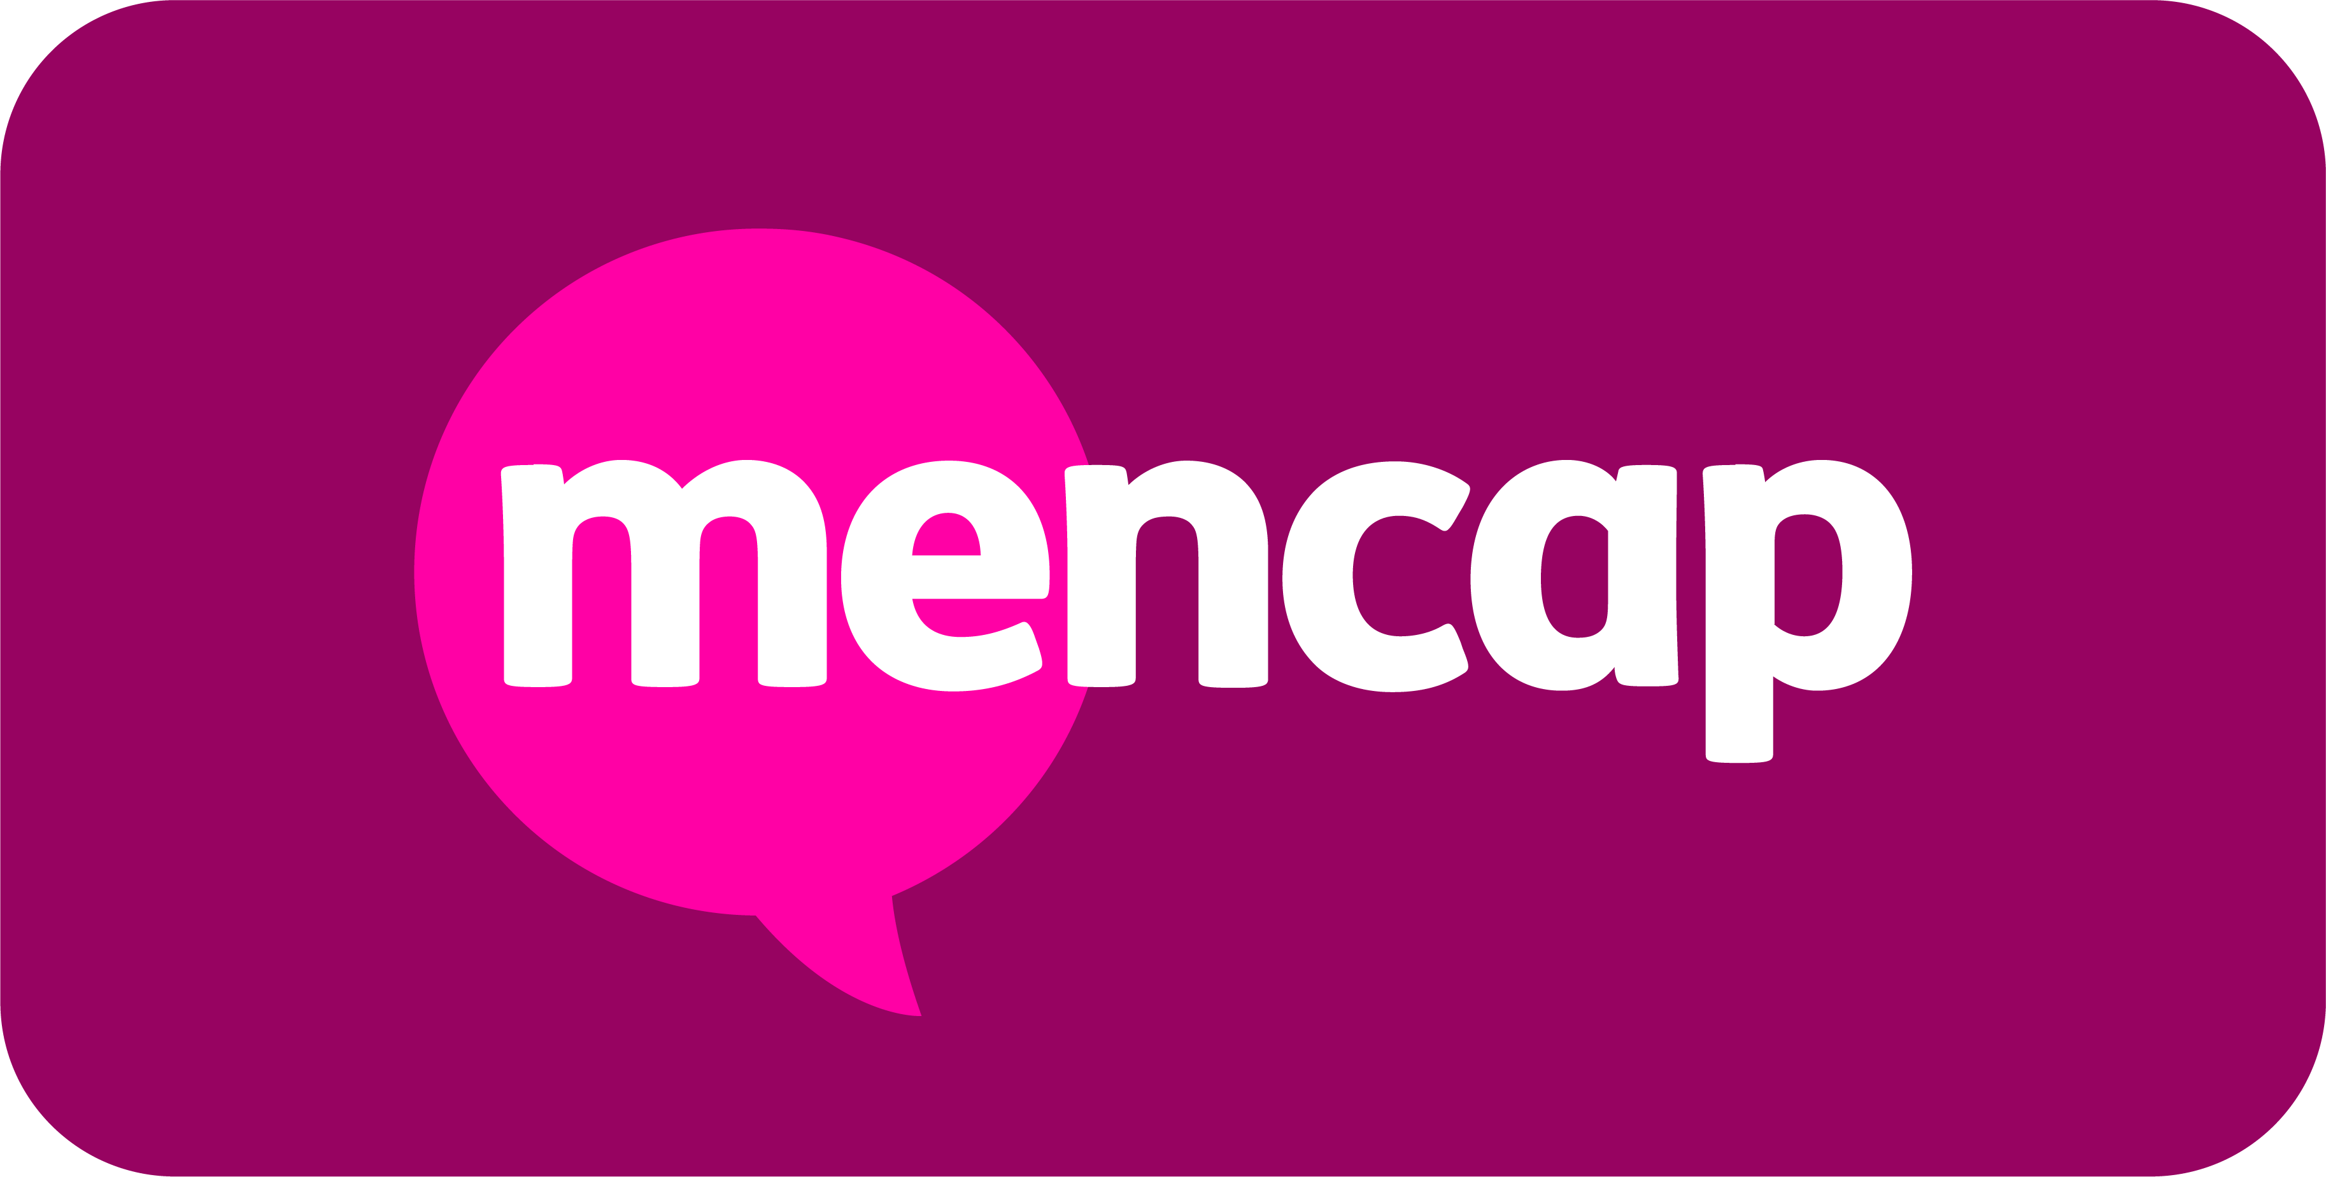

|  |
| --- |
| **About the role**  We’re looking for a motivated and enthusiastic person to join our team. In this role, you’ll play a key part connecting colleagues to our vision, making sure our colleagues get accessible information and that their voices are heard. You will:   * Lead on several of Mencap’s internal communication channels and engagement forums, including our manager communications and colleague forum. * Take the lead on gathering and sharing interesting and engaging content from across the organisation. ​ * Support with the day-to-day delivery of communication and engagement plans; supporting internal communications and engagement planning for key projects and teams across Mencap.​ * Work with stakeholders from across the whole organisation, with an emphasis on maintaining high levels of trust, influence and credibility both personally and for the team.   The role sits within a well-established and high performing team, and reports into the internal comms and engagement lead.  We are always looking for ways to improve how we communicate with and engage our colleagues. This role brings exciting opportunities to introduce fresh ideas and innovations, challenge current practices and think creatively about how internal communications can support Mencap’s wider strategic aims. |

|  |
| --- |
| **What you will bring to the role**  We are looking for someone with a desire to know more about learning disability and an understanding of accessible communication. You will bring key skills such as…   * Clear and engaging copy writing, excellent editing skills and a strong attention to detail. * Strong organisational skills to manage multiple communication projects and meet regular channel deadlines. * Good design skills to create engaging and effective content for different audiences. * Excellent relationship building skills, being able to establish and develop relationships and trust with everyone you meet. ​ * Creativity, new ideas and a passion for communication   You’ll have experience in:   * Creating and delivering high-quality, engaging communication campaigns, using a variety of channels including newsletters, intranet, emails, social networks and digital signage. * Using email marketing, editing intranet or web content and using enterprise social networks (Viva engage desirable).​​ * Delivering staff engagement activities such as events, briefings or workshops. * Communicating and influencing stakeholders at all levels and maintaining strong working relationships.​ * Photo and video editing skills and design skills are desirable.​ |

|  |
| --- |
|   **“This isn’t just a job - it’s a chance to help change the lives of people**  **with a learning disability and their families. If you’re passionate about  making a difference, join Mencap in building a more inclusive future.”** |

|  |
| --- |
| **What you can expect from Mencap**  We offer benefits such as   * **Competitive annual salary** * **24 days annual leave + all UK bank holidays** * **Amazing benefits + pension** * **Full support in the role and training** * **Flexible working options** * **Plus, many more fantastic benefits** |

|  |
| --- |
| **How to apply**  Please apply with an up-to-date CV and cover letter that demonstrates your skills and experiences relevant to this position. I**f you require any further information, please contact our Recruitment team on 01733 246699** |