|  |
| --- |
| **Regional Volunteering Coordinator – North East and Northern Ireland****(Fixed term, full time, one year maternity contract)** |
|  |
|  |
|  |

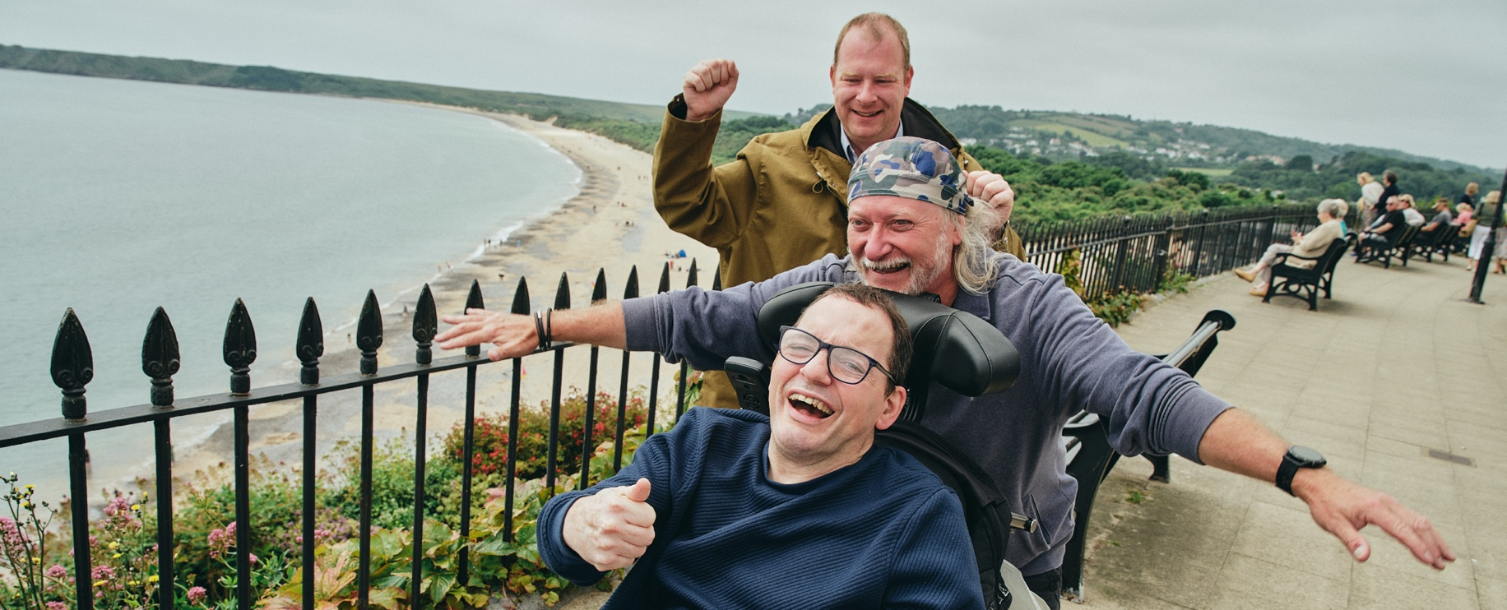

|  |
| --- |
| **About the Team and the Role**  An exciting opportunity has arisen for a passionate and committed individual to join Mencap as a Regional Volunteering Coordinator – supporting volunteering activity across the North East of England and Northern Ireland. This role sits within the Volunteering and Inclusion team, who are responsible for supporting volunteering and inclusion best practice and activities across the organisation. We currently support around 2000 volunteers a year and are growing quickly with an ambitious new volunteering strategy that aims to help us support even more people with learning disabilities to live their best lives, through the support of our volunteers. Our volunteers support a wide range of activities, from befriending volunteering, retail volunteering, events and corporate volunteering, as well as supporting our campaigns, fundraising, quality and communications teams with their skills and expertise to name just a few!  In this role you will provide direct support and expertise to our volunteer managers in Mencap teams in the North East and Northern Ireland ensuring a quality approach and sharing great practice across all volunteering activities, as well as directly managing the Mencap Visiting Service (MVS) volunteers, a befriending service to adults with a learning disability.  At Mencap, we value a diverse and inclusive workplace, and we intentionally plan for the success of our colleagues in everything we do. We welcome applications from everyone, so come as you are and join us. Together we are Mencap!  **The salary for this role is £32,954** and the hours are 37.5 a week (full time). The maternity cover contract will be until January 29th 2027 when we expect the person on maternity leave to return.  **The counties you are responsible for in this region are:** Northumberland, Tyne and Wear, North Yorkshire, East Ridings of Yorkshire, West Yorkshire, Durham, South Yorkshire, Nottinghamshire, Lincolnshire and Northern Ireland. In person visits to Northern Ireland are limited to no more than twice a year. With this role you would manage your own calendar and schedule for your travel, all work travel costs are covered by Mencap. So that we can best support and recruit our volunteers, this can include occasional evening and weekend working.  A **FULL** valid driver’s licence, with access to a vehicle you can use for business purposes is essential to be considered for this post, you must be willing to travel across your geographical area with occasional overnight stays further afield in the UK when required. Mileage and any accommodation (if required) will be paid for by Mencap. Generally, you will work from home in between travel with work.  **Please apply using an up to date CV and covering letter by Monday 29th September at 10am.** First round interviews will take place in person on **Thursday 9th October** (likely in Leeds) with a second round with our Learning Disability Panel online shortly after.  Have a question about the role? Please reach out to the line manager Matt Hatt on [matt.hatt@mencap.org.uk](mailto:matt.hatt@mencap.org.uk) |

|  |
| --- |
| **What you are responsible for in this role**   * To liaise with teams throughout your region to develop partnerships and assess their volunteering needs to see how we can support their work with volunteers * Deliver the Mencap Visiting Service within your geographical area through the recruitment induction and supervision of volunteers, a robust and flexible matching, and managing communications, and ongoing training and development requirements for all volunteers in the area * Provide ongoing one to one visits to people we support on MVS that have more complex and multiple disabilities * Keeping on top of processing and managing the volunteer data in our Volunteering systems * Generate appropriate volunteering opportunities and role profiles and promote these regionally working closely with Mencap teams - growing the number of opportunities for volunteers to support our charitable mission * Support teams with recruitment, induction, and management of volunteers as well as with creating truly accessible and inclusive volunteer roles within your region * Be a point of escalation for any challenges teams have with their volunteers within your region * Support wider projects across the Volunteering and Inclusion Team   To be successful in this role you will need a background in recruiting and managing volunteers or staff and have superb communication and interpersonal skills. You will be an excellent relationship builder and able to establish ways in which volunteers can enhance teams work. You will be motivated and driven to help us achieve our goals, and will be a creative problem solver. You will have a keen eye for detail with the ability to frequently work to tight deadlines. You will have experience of supporting multiple projects at once that may all be moving forward with different timelines. Ideally you will understand the rights and needs of people with a learning disability and have an idea of the structure of learning disability services and the support that is provided.  Bringing to life our values of passionate, positive, brave, kind and inclusive are key to ensuring you are successful in this post.  **Please note:** This job description is not intended to be exhaustive. Duties and responsibilities may evolve over time to reflect the needs of the organisation and the role. |

|  |
| --- |
|   **“This isn’t just a job - it’s a chance to help change the lives of people**  **with a learning disability and their families. If you’re passionate about  making a difference, join Mencap in building a more inclusive future.”** |

|  |
| --- |
| **Mencap and our Commitment to Safeguarding**  *Mencap is committed to safeguarding and promoting the welfare of children, young people and vulnerable adults, and expects all staff and volunteers to share this commitment.*  *Successful applicants will be subject to appropriate pre-employment checks, including references and, an enhanced Disclosure and Barring Service (DBS) check.* |