Supported Living Transition Manager
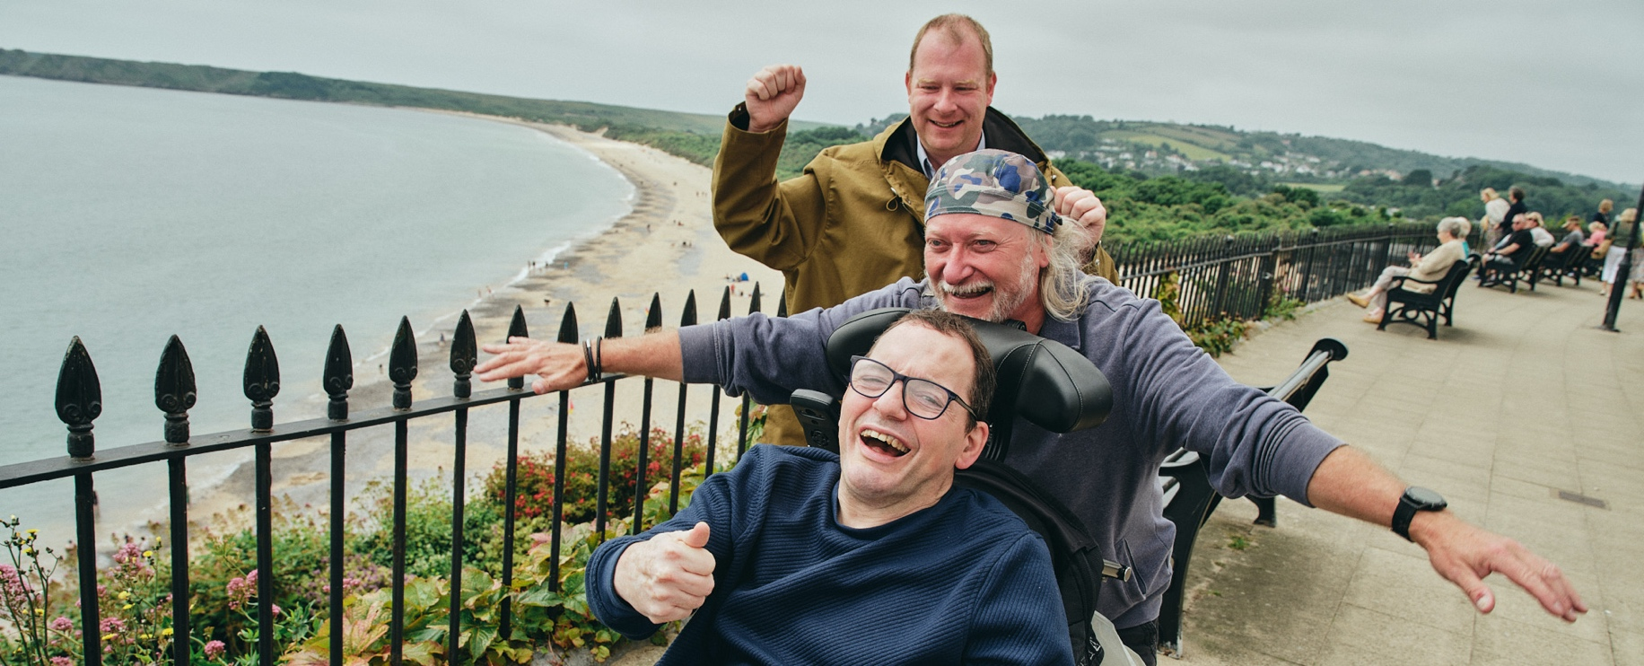
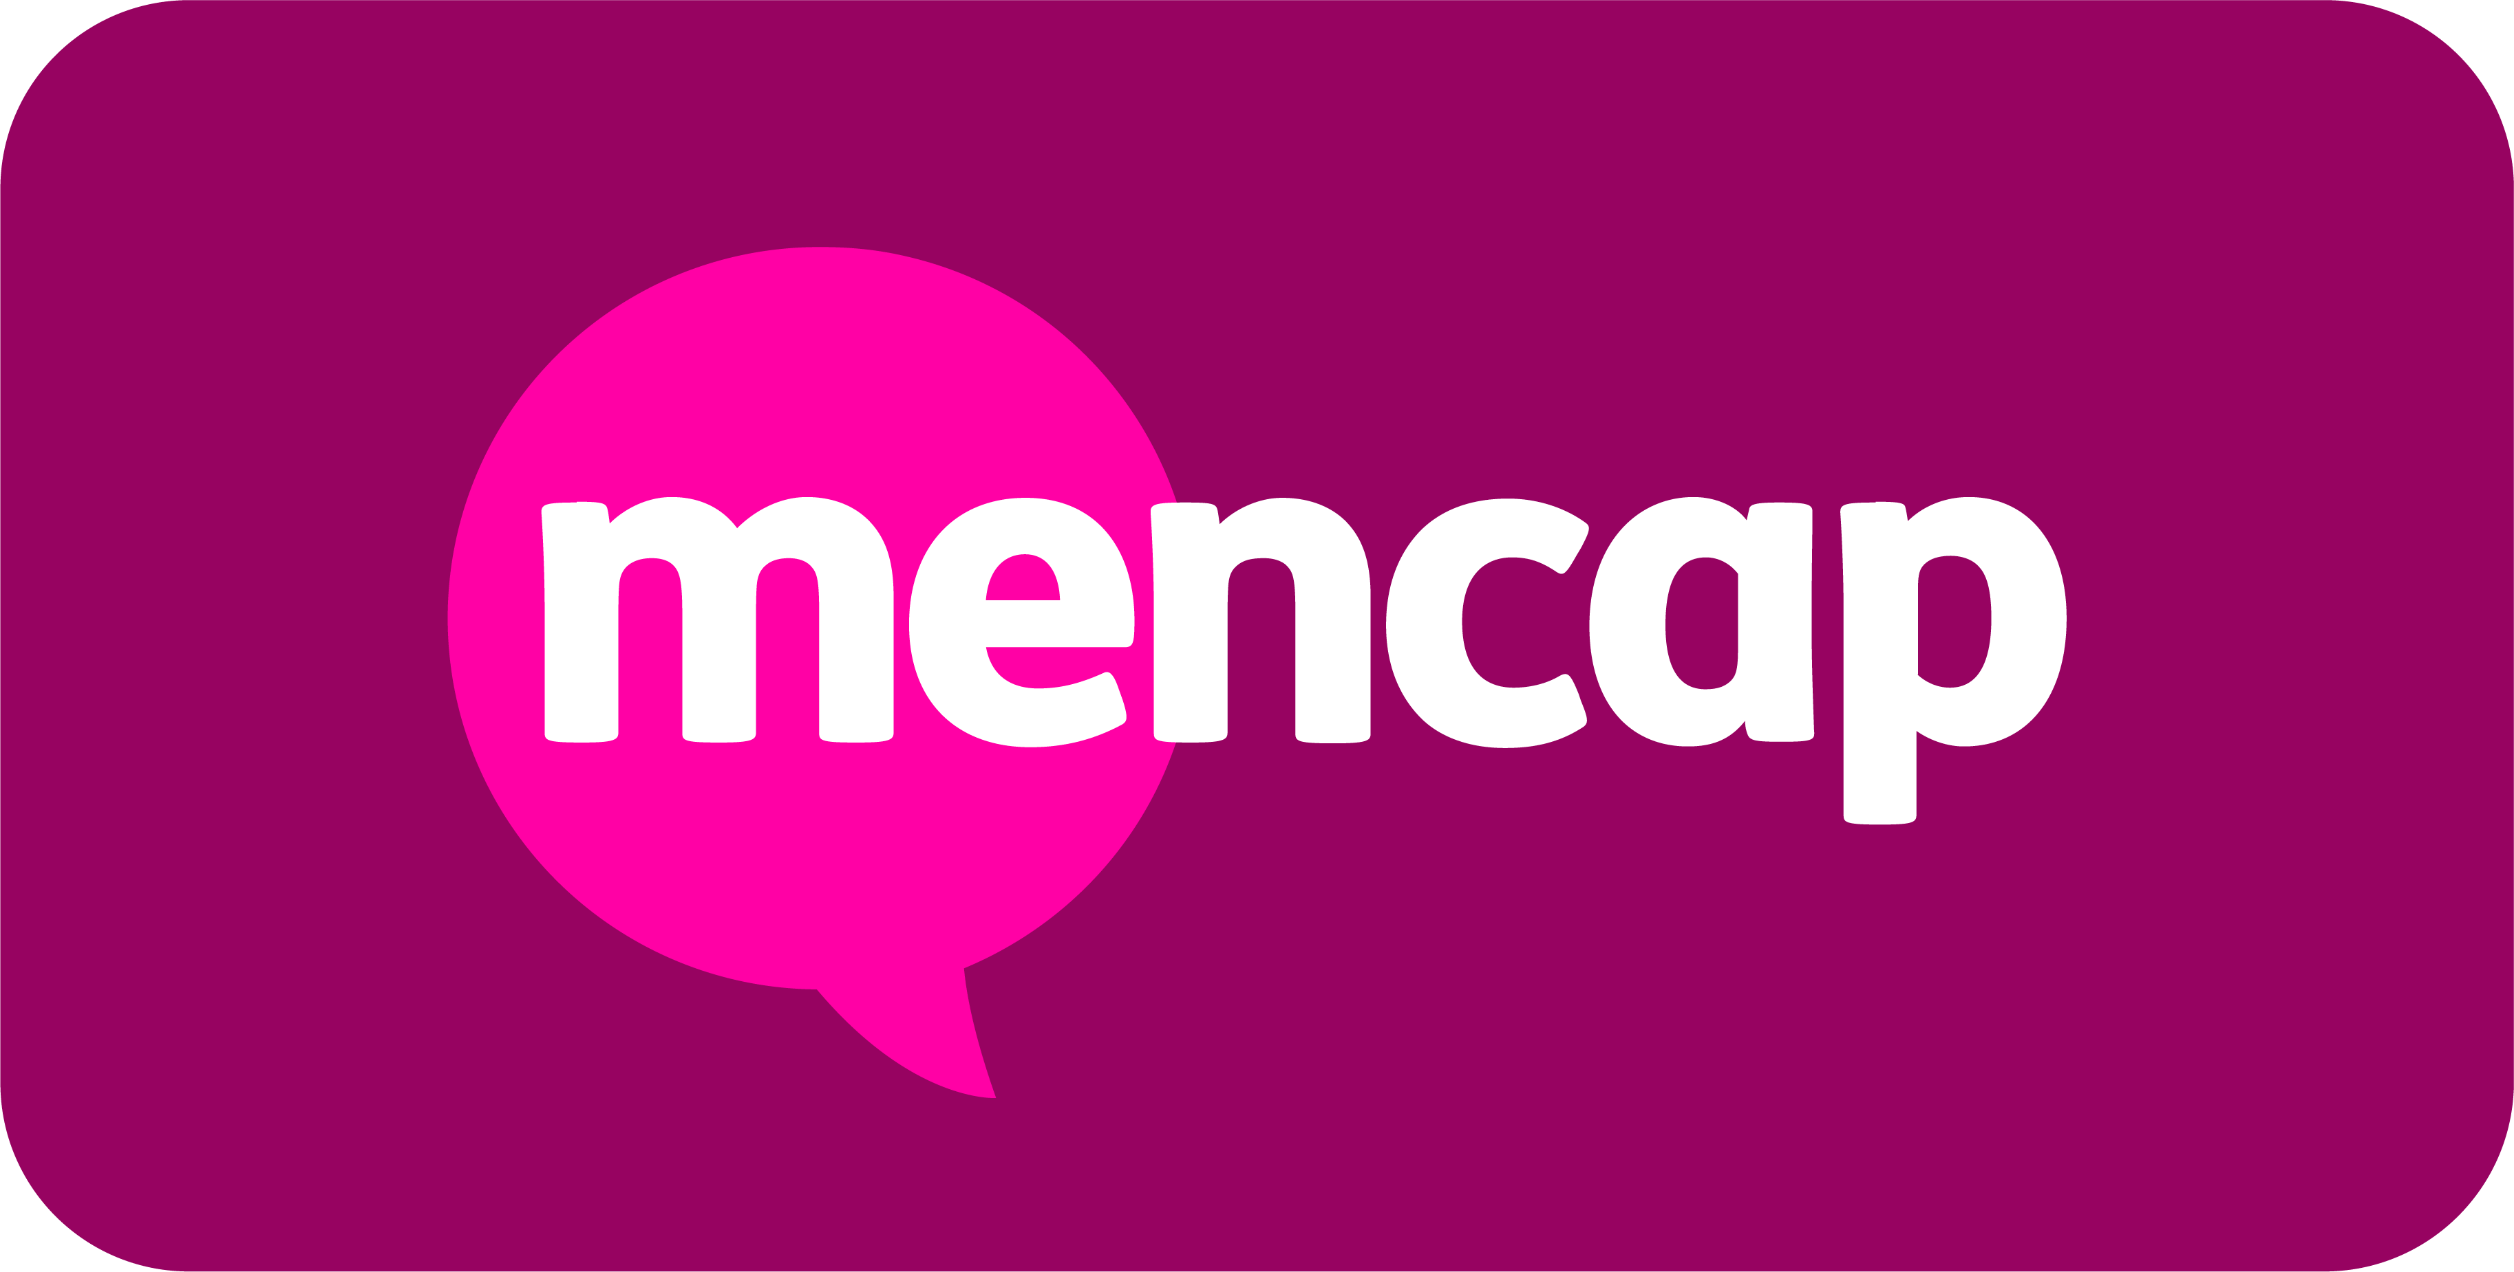

About the Team and the Role

- Lead and coordinate the transition of adults with a learning disability into personalised, community-based supported living arrangement, enabling individuals to live independently with the right support tailored to their needs, preferences, and aspirations.
- Manage day-to-day project delivery with robust governance, clear milestones, and effective risk management, including issues and escalations, reporting progress to the NI Head of Engagement and Development. This includes the establishment of an internal project management group that will meet with the Head of Engagement and Development, NI Regional Operations Manager, Director of Northern Ireland and other key contributors.
- Work collaboratively with individuals, their families, and relevant health and social care professionals to shape a personalised transition plan. This will be informed by the assessment and referral process, care and support planning, and early in-reach and pre-planning activity to ensure a well-prepared and person-centred move into community-based support.
- Ensure suitable accommodation, staffing, and regulatory compliance with RQIA standards to support a smooth move into supported living.
- Support the business development directorate to secure funding and resources in collaboration with commissioning bodies and finance teams, while working with the Quality Team and Operating Model Lead to shape the organisation’s future model for specialist care and support.
- Build, recruit, and develop a dedicated team to deliver high-quality, person-centred care.
- Success will be measured by a safe and well-planned transition, compliance with RQIA standards, and meaningful outcomes for each individual - including greater autonomy, choice, and an improved quality of life, supported in a way that reflects their needs and aspirations.


What you will bring to the role (Essentials)

- Comprehensive management experience within health and social care, including leading teams and services.
- Strong knowledge of RQIA regulatory framework and standards in Northern Ireland.
- Proven experience in project management, including planning, risk management, and delivery of complex, cross-organisational transformation or change projects.
- Direct experience supporting individuals transitioning from hospital to community settings.
- Demonstrable experience of working with individuals, families, and multi-agency contributors to co-produce care and support plans, with knowledge of commissioning and housing processes in Northern Ireland.
- Excellent communication, contributor engagement, and relationship-building skills, with a strong commitment to person-centred care and inclusion.

Please note: This job description is not intended to be exhaustive. Duties and responsibilities may evolve over time to reflect the needs of the organisation and the role.



“This isn’t just a job - it’s a chance to help change the lives of people
with a learning disability and their families. If you’re passionate about
making a difference, join Mencap in building a more inclusive future.”

Mencap and our Commitment to Safeguarding
Mencap is committed to safeguarding and promoting the welfare of children, young people and vulnerable adults, and expects all staff and volunteers to share this commitment.
Successful applicants will be subject to appropriate pre-employment checks, including references and, where applicable, an enhanced AccessNI check.

