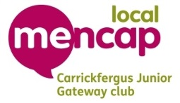Job description

Job title – Leader
Main tasks – attending each week or as frequently as possible. Participating in activities with our members, whether that is playing sports with them, colouring in, playing a games console. Engaging with our members and getting to know them.
Time Commitment – We run each Thursday evening from 6:30-9:30 pm, 3 hours per week.
Location – We run out of Sunnylands Youth Centre, Carrickfergus, BT38 8ED.
Skills and qualities – None needed

Please note this is a voluntary position as is all positions in our organisation, tbere are no paid members of staff.

