About the Team and the Role
- This role sits within the Communications function and is vital to ensuring that Mencap can put people with lived experience at the heart of all of our communications activities.
- This role, and that of the wider Communications Team, is fundamental to Mencap’s work to break down barriers in society for people with a learning disability. We work hard to educate the public about life with a learning disability and, in turn, to influence relevant policy decisions.
- The person in this role will proactively find and follow up on leads of people with a learning disability and those close to them, capturing their experiences to share on suitable channels.
- Interview people to get the best from them and use journalistic skills to capture the elements of their story that are most effective at raising awareness of learning disability and showing the impact of Mencap’s work.
- Develop and create engaging multimedia content featuring storytellers, to appeal to a wide range of audiences. This could include written copy, web pages, graphics, still images, videos.
- Maintain and develop relationships with lived-experience ambassadors, supporters, influencers and other individuals with a personal connection to learning disability, helping to identify and share stories that support Mencap’s communications objectives.
- Coordinate and manage the logistics of storyteller stewardship and content creation activities, including compiling briefing documents, scheduling interviews, organising filming opportunities, obtaining consents, and supporting contributors throughout the process.
- Maintain trusting relationships with individuals who want to tell their story.
- Save and organise story records in an accessible and effective way and managing access for other colleagues.
Stories Content Officer

What you will bring to the role (Essentials)
- Experienced in interviewing individuals and communicating their personal stories.
- Skilled at identifying and crafting compelling narratives that resonate with diverse audiences, including media outlets.
- Able to write engaging copy for written outlets, including web stories or blog posts.
- Capable of recording basic videos using a phone and external microphone.
- Proficient in basic video editing and subtitling using tools like Kapwing or Adobe Premiere.
- Able to create simple graphics using Canva.
- Some experience working with people with learning disabilities and/or additional needs (desirable).

Please note: This job description is not intended to be exhaustive. Duties and responsibilities may evolve over time to reflect the needs of the organisation and the role.

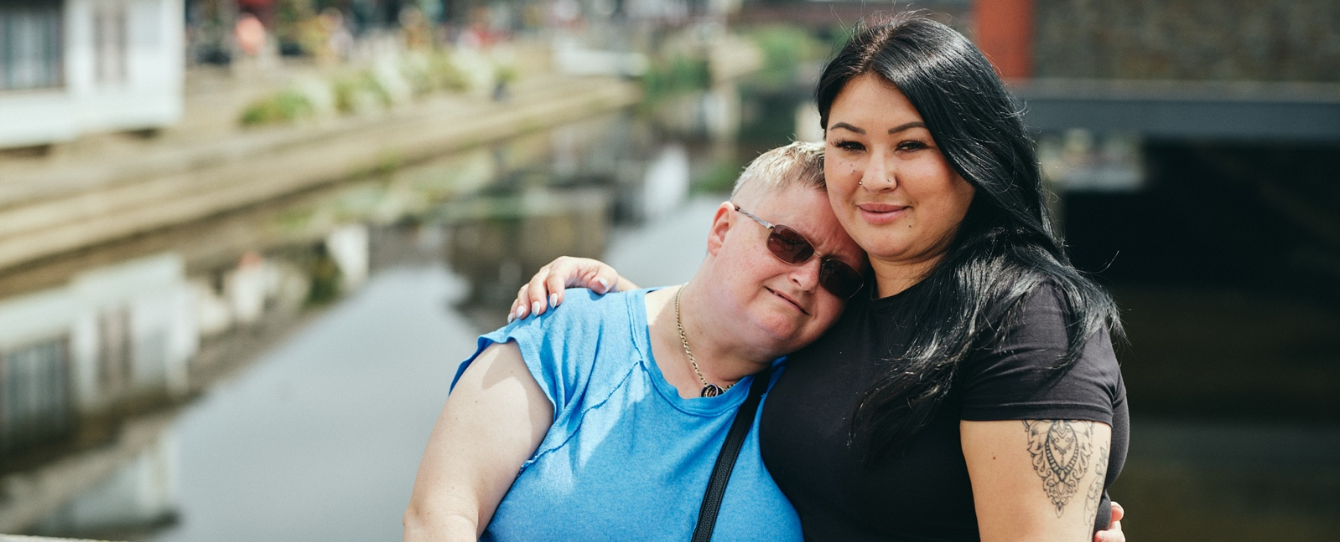

“This isn’t just a job - it’s a chance to help change the lives of people
with a learning disability and their families. If you’re passionate about
making a difference, join Mencap in building a more inclusive future.”

Mencap and our Commitment to Safeguarding
Mencap is committed to safeguarding and promoting the welfare of children, young people and vulnerable adults, and expects all staff and volunteers to share this commitment.
Successful applicants will be subject to appropriate pre-employment checks, including references and an enhanced Disclosure and Barring Service (DBS) check.

